To Access Subscription’s Resource:

Go to Home > Subscriptions:

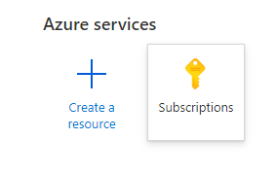

Click within the search text box and start typing either the name or a key part of the name (Such as BPC in this case). The subscriptions will automatically start the search as you type.

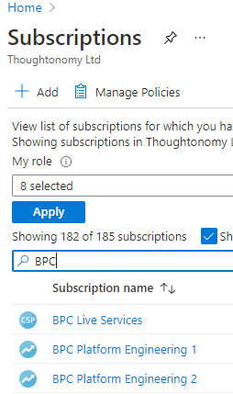

Click on the subscription that you want to get access.



Now click on “Resources” > Then click on the “Type” column name to sort the resources.

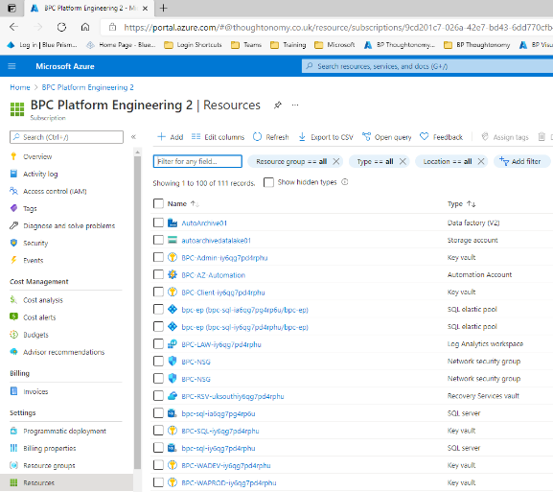

Right click on the key vault and open it in another tab.

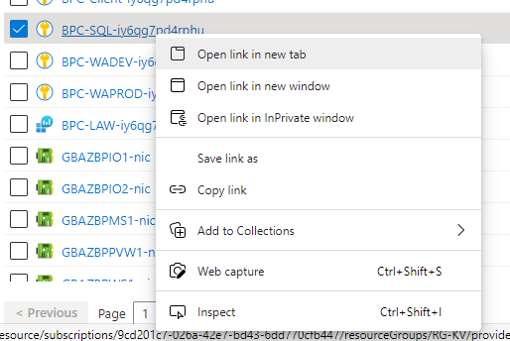

Under the settings tab within the Key Vault, select what is required to access the resource. In this case “Secrets” was selected.

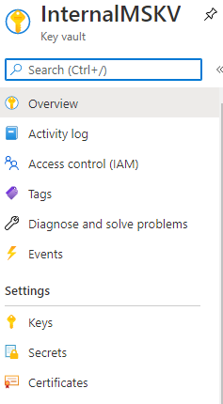

Click the resource you intend to use to reveal the Secrets (userid and password).

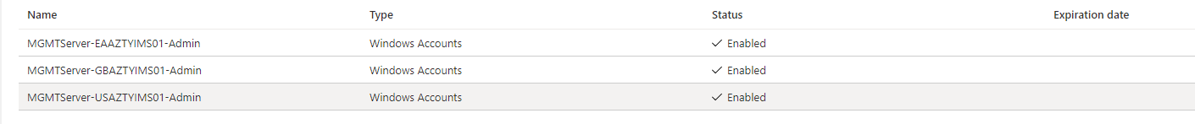

Click on the Current Version key

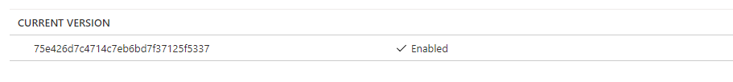

Click on the Tags area.

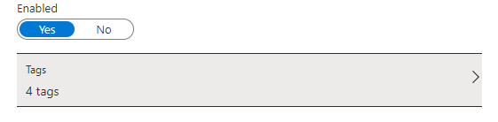

Note the Username located within the right side pop out window (to the right of the tagname).

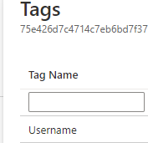

Click on the Secret Value copy button.

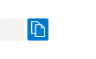

Return to the Subscription’s Resources page, Locate and click on the resource which you intend to use.

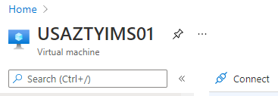

Click on the connect button then choose RDP.

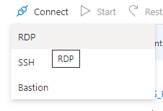

Select “My IP” from the Source IP area, then select Request Access.

